Jahangirnagar University (JU)



**Institute of Information Technology**

**Lab Report-4**

Assembly Language

**Name:** Md. Shakil Hossain **Roll:** 2023

# Experiment 1:

Case conversion

1. upper case to lower case and vice versa

# Algorithm:

**Upper case to lower case**

1. Load the input character into a register.
2. Compare the input character with the ASCII value of 'A' (41h).
3. If the input character is less than 'A', jump to step 7.
4. Compare the input character with the ASCII value of 'Z' (5Ah).
5. If the input character is greater than 'Z', jump to step 7.
6. Add 32 (20h) to the input character to convert it to lower case.
7. Store the converted character in a memory location or register.

**Lower case to Upper case**

1. Load the input character into a register.
2. Compare the input character with the ASCII value of 'a' (61h).
3. If the input character is less than 'a', jump to step 7.
4. Compare the input character with the ASCII value of 'z' (7Ah).
5. If the input character is greater than 'z', jump to step 7.
6. Subtract 32 (20h) from the input character to convert it to upper case.
7. Store the converted character in a memory location or register.

# Flow Chart

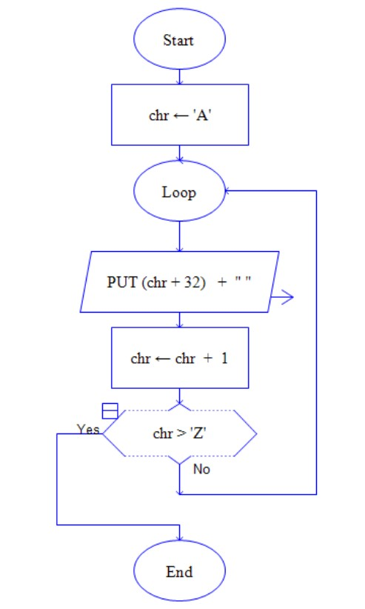

**Program Source Code:**

**Upper case to lower case**

org 100h

.model small

.data

msg1 db 13,10, "Enter upper case: $"

msg2 db 13,10, "lower case: $"

.code

main proc

mov ax,@data

mov dx,ax

mov dx,offset msg1

mov ah,9

int 21h

mov ah,1

int 21h

mov bl,al

add bl,32

mov ax,@data

mov dx,ax

mov dx,offset msg2

mov ah,9

int 21h

mov dl,bl

mov ah,2

int 21h

mov ah,4ch

int 21h

main endp

end main

ret

**Lower case to Upper case**

org 100h

.model small

.data

msg1 db 13,10, "Enter lower case: $"

msg2 db 13,10, "Upper case: $"

.code

main proc

mov ax,@data

mov dx,ax

mov dx,offset msg1

mov ah,9

int 21h

mov ah,1

int 21h

mov bl,al

sub bl,32

mov ax,@data

mov dx,ax

mov dx,offset msg2

mov ah,9

int 21h

mov dl,bl

mov ah,2

int 21h

mov ah,4ch

int 21h

main endp

end main

ret

**Sample Input: A**

**Sample Output: a**

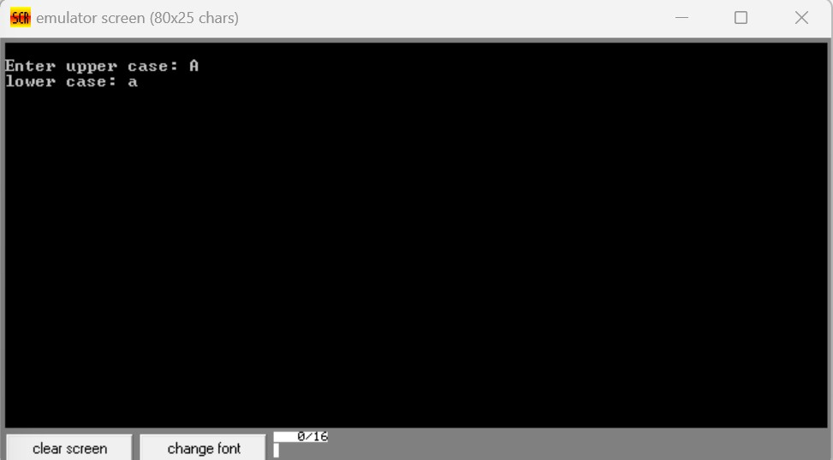

**Sample Input: a**

**Sample Output: A**

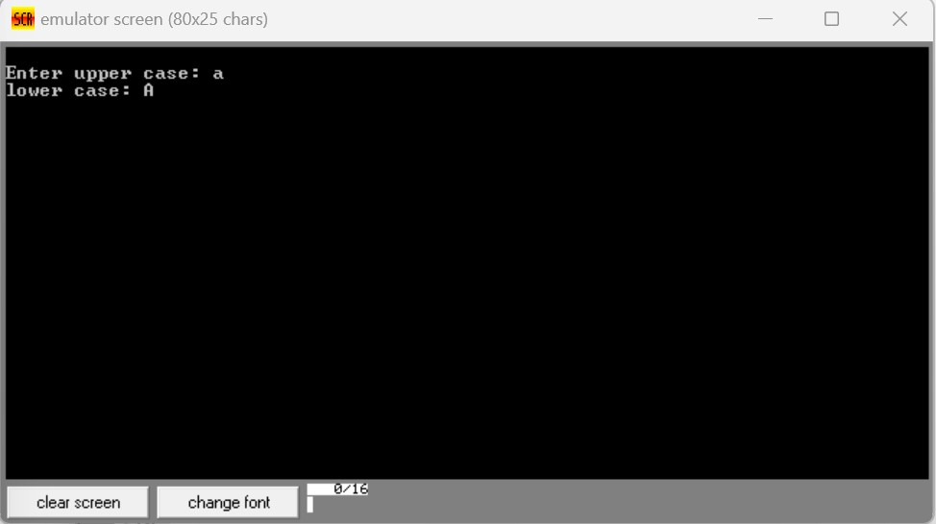

# Experiment 2:

Compare three digits and find the biggest number

# Algorithm:

1. Load the first digit into a register.
2. Load the second digit into another register.
3. Compare the first and second digits.
4. If the first digit is less than the second digit, store the second digit in the first digit's register.
5. Load the third digit into another register.
6. Compare the first digit with the third digit.
7. If the first digit is less than the third digit, store the third digit in the first digit's register.
8. The first digit's register now contains the largest of the three digits.

# Flow Chart:

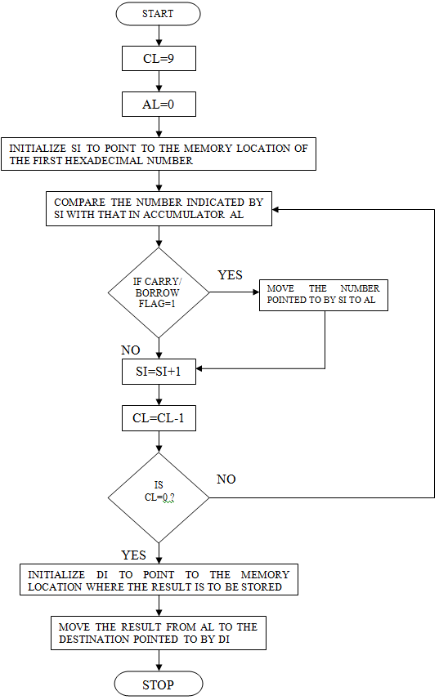

**Program Source Code:**

org 100h

.model small

.data

msg1 db 10,13,"Enter First Number : $"

msg2 db 10,13,"Enter Second Number : $"

msg3 db 10,13,"Enter Third Number : $"

msg4 db 10,13,"Large Number : $"

num1 db ?

num2 db ?

num3 db ?

.code

main proc

mov ax, @data

mov ds, ax

lea dx, msg1

mov ah, 9

int 21h

mov ah, 1

int 21h

mov num1, al

lea dx, msg2

mov ah, 9

int 21h

mov ah, 1

int 21h

mov num2, al

lea dx, msg3

mov ah, 9

int 21h

mov ah, 1

int 21h

mov num3, al

lea dx, msg4

mov ah, 9

int 21h

mov bl, num1

cmp bl, num2

jng number2

cmp bl, num3

jng number3

mov dl, num1

jmp display

number2:

mov bl, num2

cmp bl, num3

jng number3

number3:

mov dl, num3

display:

mov ah, 2

int 21h

main endp

ret

**Sample Input: 8, 2, 6**

**Sample Output: 8**

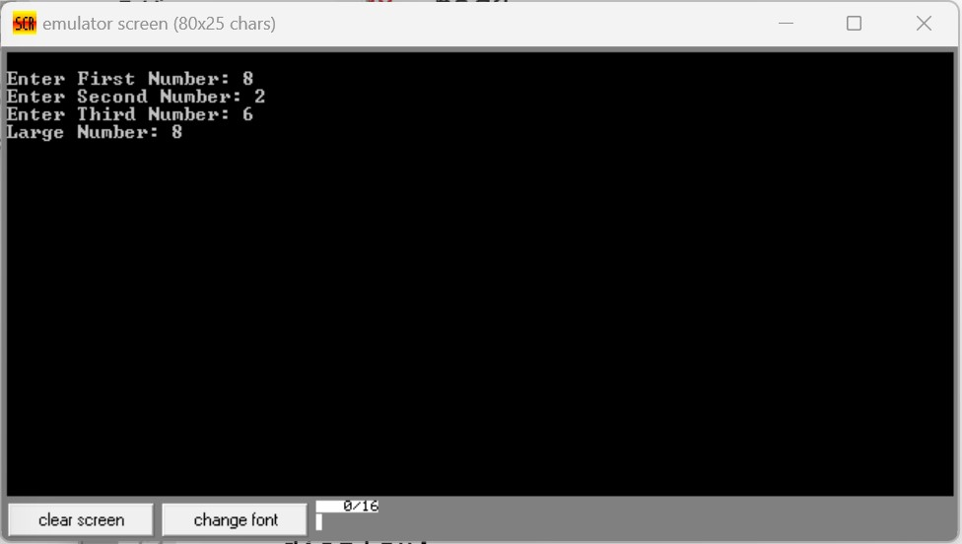

**THE END**